**Software Design Specification**

**1. Introduction**

**1.1 Purpose of this document**

The Software Design Specification (SDS) document will

(a) focuses on specifying a high-level view of the architecture of our system,

    and on the interaction between the user and the system.

(b) focus on detailing a low-level view of each component of the software and

     how the components interact with each other.

This document will elaborate the working of the DADA(Dumb and Deaf Assistance).

**1.2 Scope of the development project**

DADA provides better communication and lives easier. Objective of this product is to build connectedness among people and to reduce challenges faced by dumb and deaf. It can also help the teachers who teach them.

**1.3 Definitions, acronyms, and abbreviations**

a. DADA: Deaf and Dumb Assistance.

b. SRS: Software Requirements Specification.

d. ROI: Region of Image.

e. ASL : American Sign Language

**1.4 References**

  NA

**1.5 Overview of document**

The System architecture description section is the main focus of this document.  It

provides an overview of the system’s major components and architecture, as well as

specifications on the interaction between the system and the user.

In section 4, we detail the steps that we are taking to focus on code reuse in this

software, and we explain our motives for doing so.

Section 5 lists the major decisions we had to make when designing our system, and

why we made the choices we did.

The Pseudocode section will provide pseudocode in order to clarify the intended

operation of certain components.

**2. Conceptual Architecture/Architecture Diagram**

**Client Server Architecture**

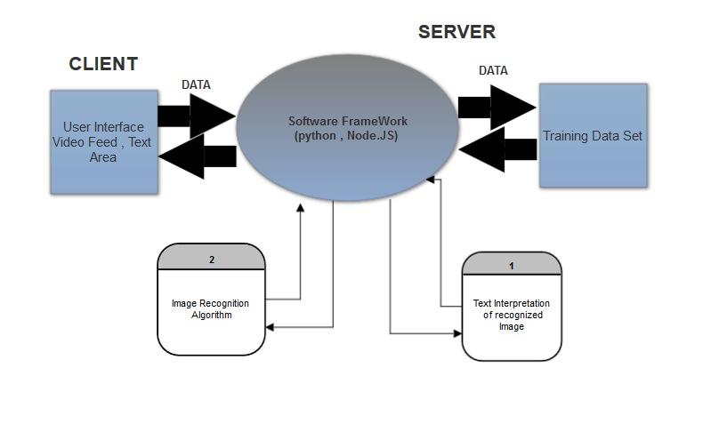

**2.1 Overview of modules / components**

The Structure of Our project is Highly modularized. For Web Interface we have tried to use MVC(Model View Control) so that we can seprate and manage various Components Effectively.

1. Stream Web Cam

2.Get and Set Context

3.Read Image

4.Process Image

5.Show Text

**2.2 Structure and relationships**

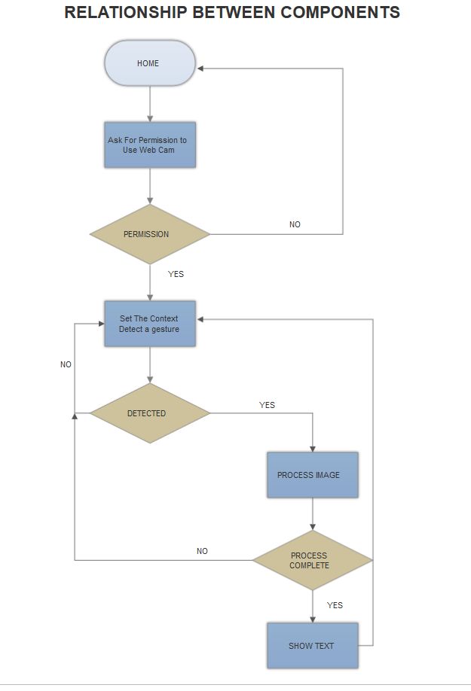

**.**

**2.3 User interface**

User Interface is designed in 3 Components . These are :

1. Navigation Bar which contains the project name

2. Video canvas element which displays the feed from the webcam.

3. Text area where the interpreted text will be displayed after processing.

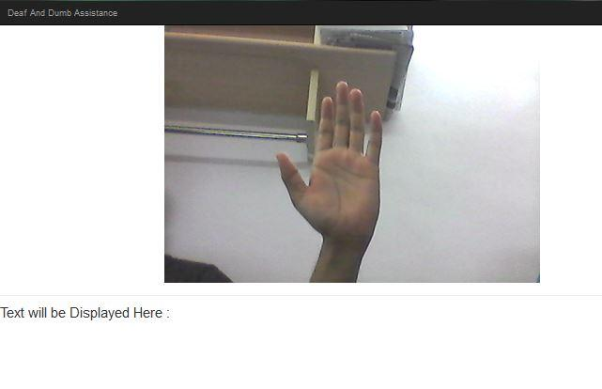

**3. Logical Architecture (Class Diagram, Sequence Diagram, State Diagram)**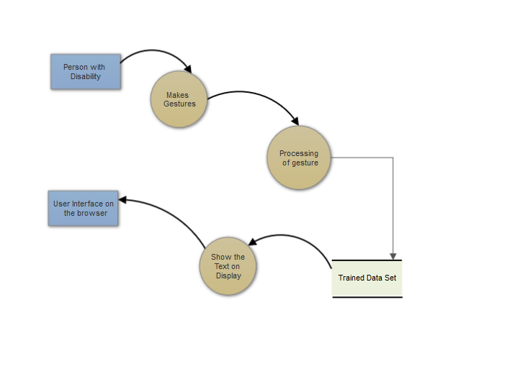

**DATA FLOW DIAGRAM :**

**SEQUENCE DIAGRAM :**

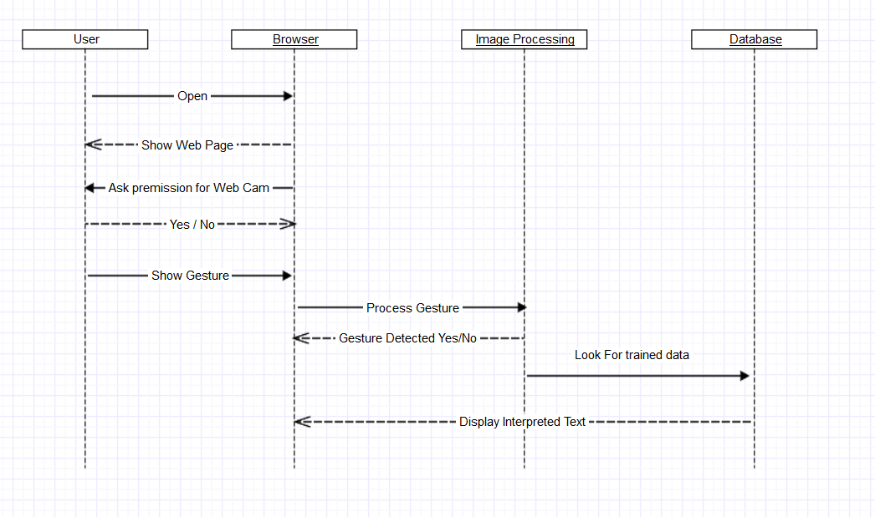

**STATE DIAGRAM :**

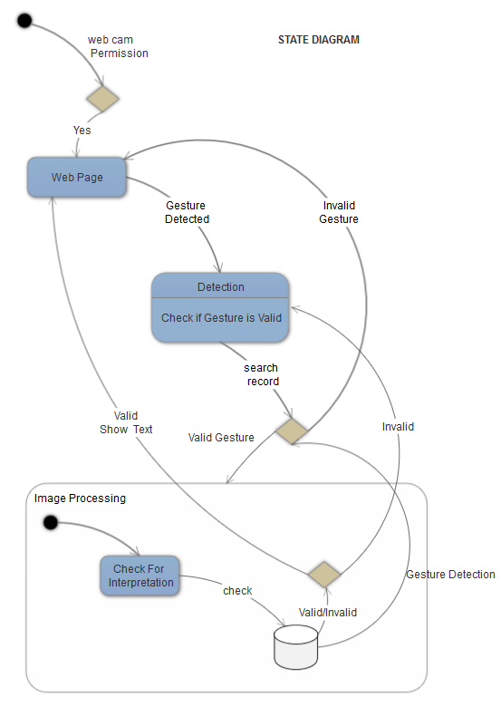

**4.0 Execution Architecture**

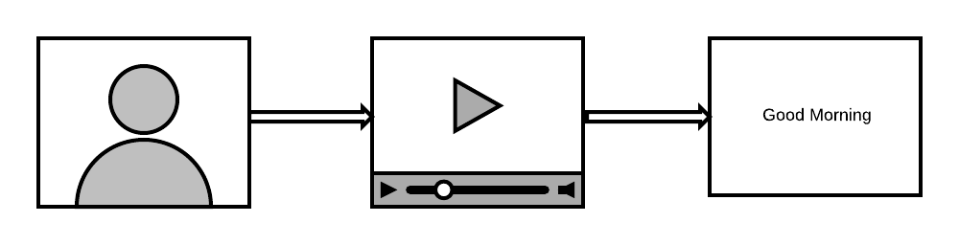

In good light conditions user performs sign language, waits for the processing and then text output is shown on the screen.

**4.1 Reuse and relationships to other products**

The most amazing fact about DADA is its reusability. Version1.0 contains Web browser as front end. In version2.0 web browser is replaced by a smart phone. So with only minimal adjustments, product can be improved. And in Version3.0 which is called DADAM (Module Version of DADA) smart-phone is replaced with a RaspberryPi module. This explains you the reusability of the product.

**5.0 Design decisions and tradeoffs**

The user interface and the designs for this software are kept simple so that any person can use this functionality easily.

**6.0 Pseudocode for components**

**1. Javascript Components for Video Feed**

1.1. function streamWebCam (stream) :

create VideoURL

Video Play

1.2. function Get_Set_Context (stream) :

get Video and Canvas Element

Set Context to 2D

Ask for User Permission

Set Height and Width Attribute of video element

**2.Python Components for Image Processing**

2.1. function readImage() :

Set VideoCapture 0

Set the cascade Classifier

Show Image

2.2. function ProcessImage() :

Set the Region of Interest on the image

Set the Lower and Upper Skin HSV  value

Mask the image

apply Noise reduction Meadian Blur Technique

Place a Rectangle over detected Object

**SDS component template :**

|  |  |
| --- | --- |
| Identification | Stream Web cam |
| Type | Function |
| Purpose | To get the Video stream from the webcam to the browser |
| Subordinates | NA |
| Dependencies | Every Other Component is dependent on it because it provides main video feed. |
| Interfaces | Web Browser |
| Data | Video Stream |

|  |  |
| --- | --- |
| Identification | Get and Set context |
| Type | Function |
| Purpose | Get the id’s from the HTML tags by Jquery and also set the Context to 2D.It is mainly used to show the output to the HTML page |
| Dependencies | NA |
| Data | ID’s of various HTML tag |

|  |  |
| --- | --- |
| Identification | Read Image |
| Type | Function |
| Purpose | Purpose of this function is to feed the image processing unit frame by frame to analyse the detection and interpritation algorithm |
| Dependencies | Image Process is completely dependenent on it because it provides the main input to this function |
| Data | Video Stream |

|  |  |
| --- | --- |
| Identification | Process Image |
| Type | Function |
| Purpose | Detect the sign language and interpret the text from it. |
| Dependencies | Output to the Web App |
| Data | Frame by Frame image |

|  |  |
| --- | --- |
| Identification | Show Text |
| Type | Function |
| Purpose | Get the interpreted text from the process image and send it to the HTML area. |
| Interfaces | Web App |
| Data | Text |